**IAP PROJECT SEMESTER**

**Project Goal Report**

**Submitted by:**

(101503247) VIVEK KUMAR

BE Fourth Year, COE-11

**Under the Mentorship of**

Dr. Prashant Singh Rana

Assistant Professor



**Computer Science and Engineering Department**

**TIET, Patiala**

**23th September 2018**

**PROJECT OVERVIEW**

I’m a part of the Advanced System Technology (AST) group at ST. Here I am working in the domain of deep learning for computer vision applications majorly involved in optimizing convolutional neural network applications for ST’s heterogeneous computing platform ([Orlando](https://blog.st.com/orlando-neural-network-iot/)) consisting of multiple DSP's and other fixed function blocks.

My work involves research and development in the algorithmic domain, requiring me to explore network compression and quantization techniques, study state-of-the-art research papers and implement them.

I worked on Real Time Object Detection system called **YOLO** (You only look once) implemented in **Darknet** which is an open source neural network framework written in C and CUDA.

**GOALS OF THE PROJECT**

* **Implementing, training and testing YOLO on Darknet using Pascal VOC and Microsoft COCO datasets.**

My first task is to implement YOLO with darknet on several standard image detection datasets such as Pascal VOC and Microsoft COCO dataset.

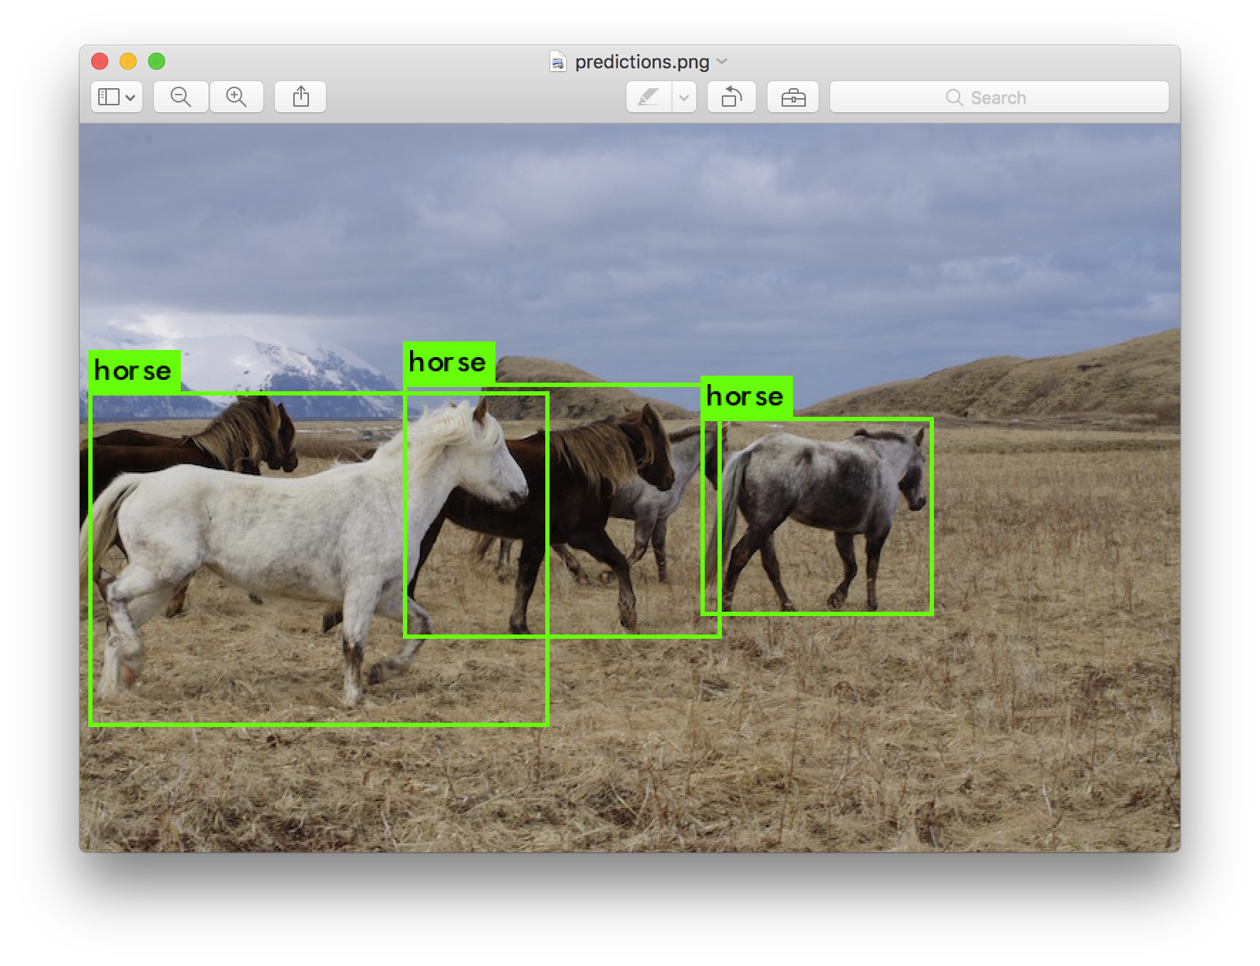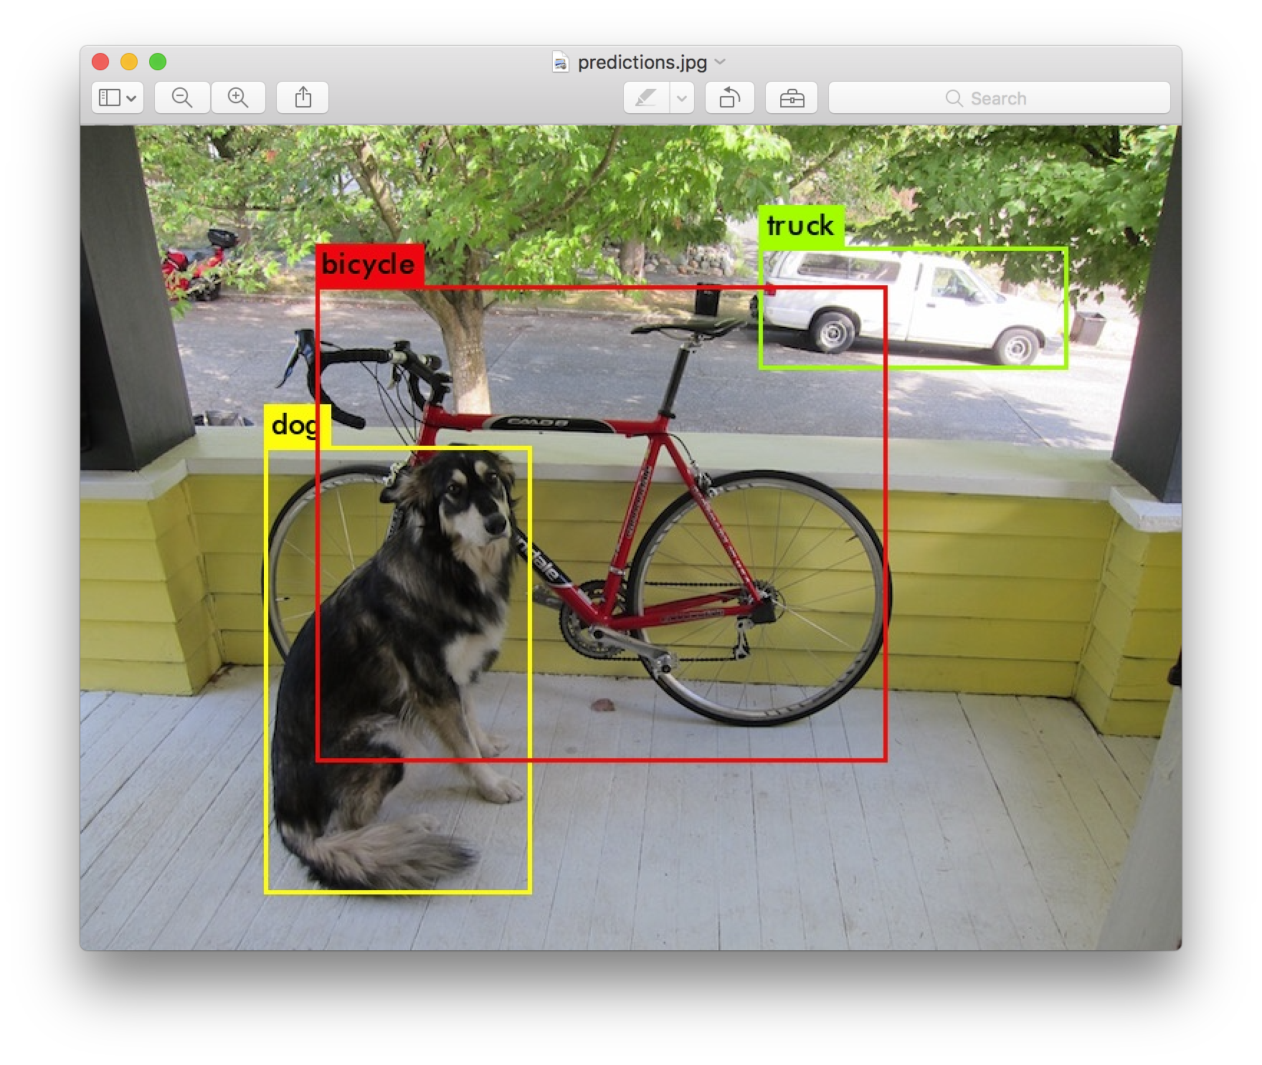

**Fig.1:** Detection using yolov3.weights **Fig.2:** Detection using yolov3.weights

* **Training and testing YOLO for subset of classes for Pascal VOC and Microsoft COCO datasets.**

Next I have to reduce the classes of predictions to some subset classes such that our systems size should be less and it work fast on our classes subset.

* **Creating GUI to launch training for subset YOLO system.**

Create a graphical user interface (GUI) to give user ability to select subset of classes on which he/she want their model to be trained. User can calculate weights of the model before even train the model in order to get insight of the size which this subset class model is going to occupy. Then user can launch the training from the click of the button.

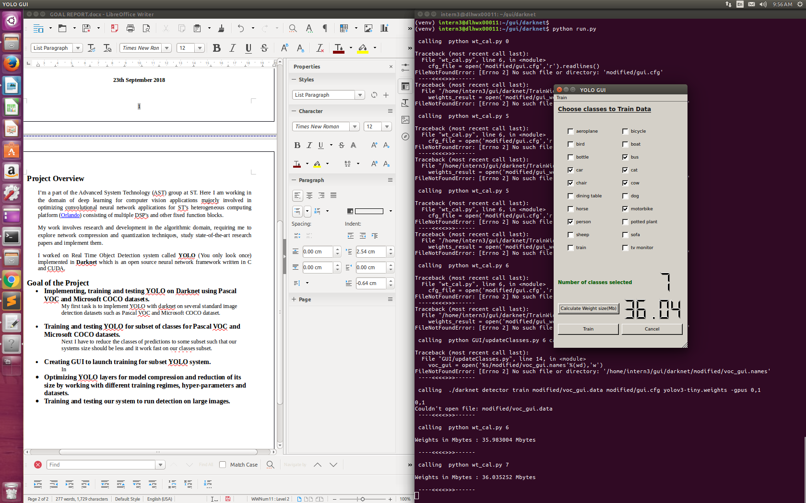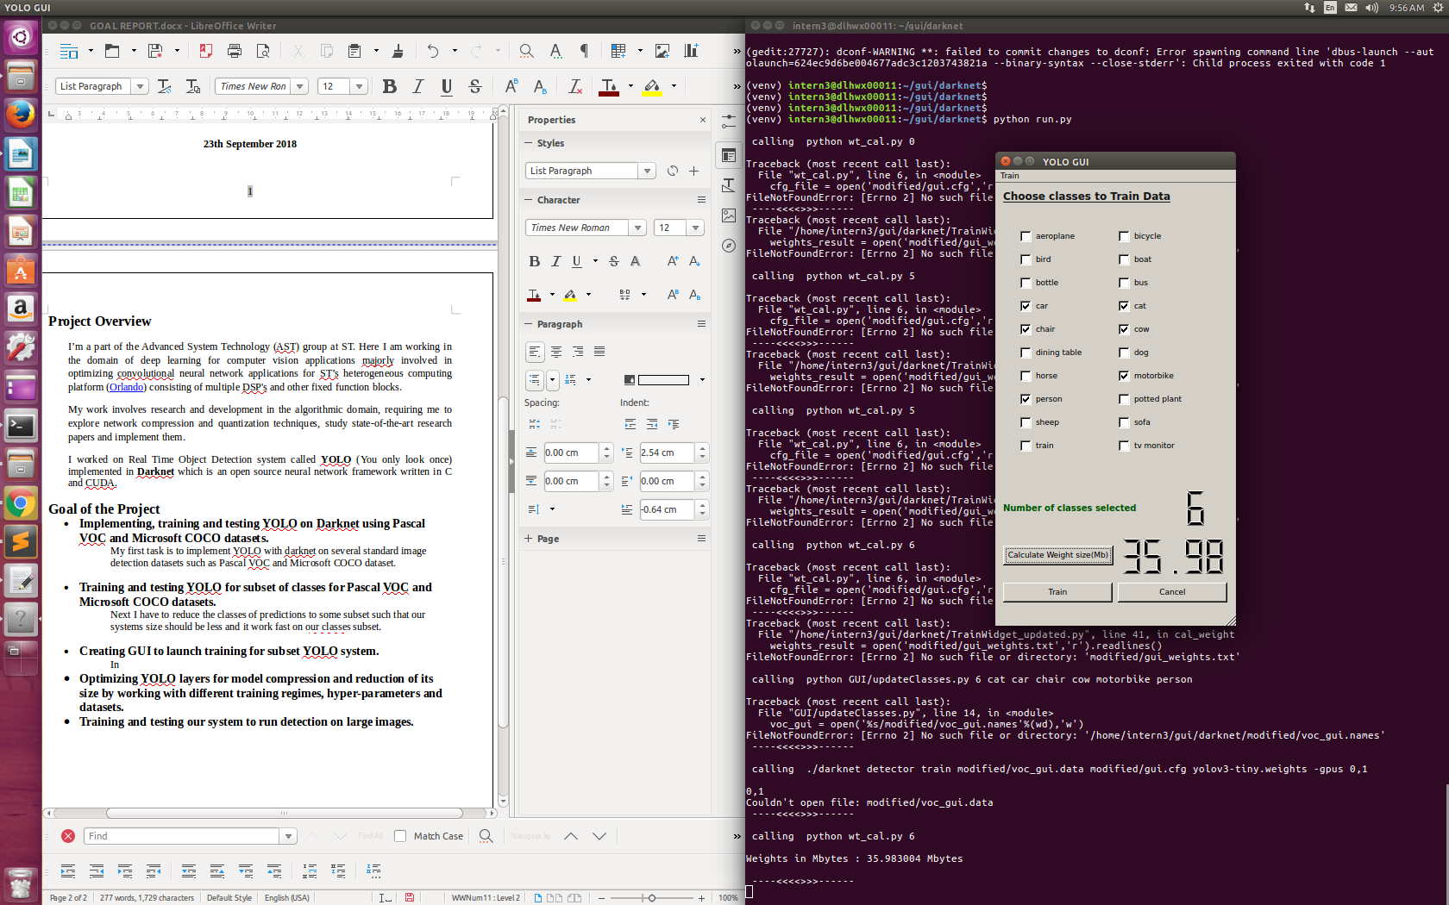

**Fig.3:** GUI with 6 classes selected **Fig.4:** GUI with 7 classes selected

* **Optimizing YOLO layers for model compression.**

Task is to reduce the size of our system to reduce it further down to below 10Mb in order to port it to ST’s SoC Orlando by working with different training regimes, hyper-parameters and datasets.

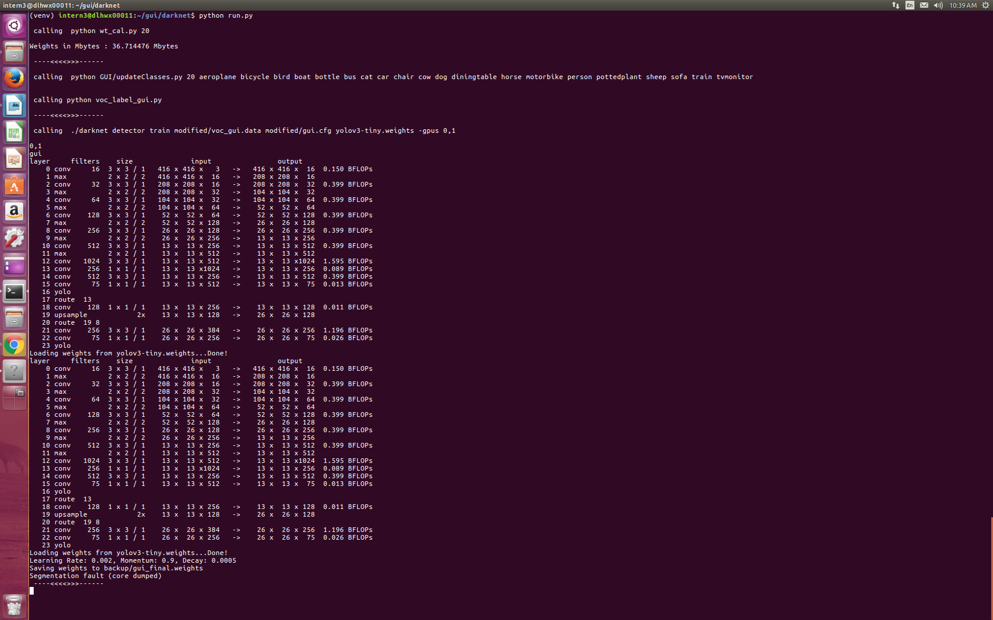

**Fig.5:** Model with 23 layers give 35-38Mb Model size

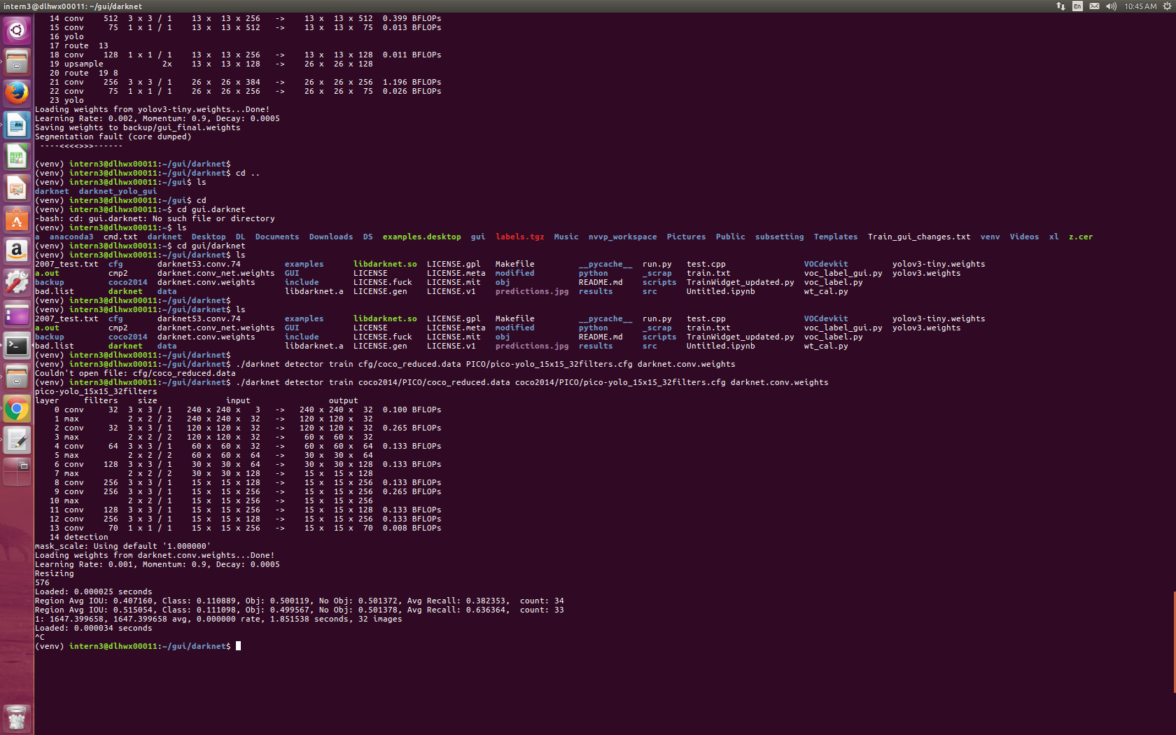

**Fig.6:** Model with 14 layers give 6-7Mb Model size

* **Training and testing our system to run detection on large images.**